**RESUME**

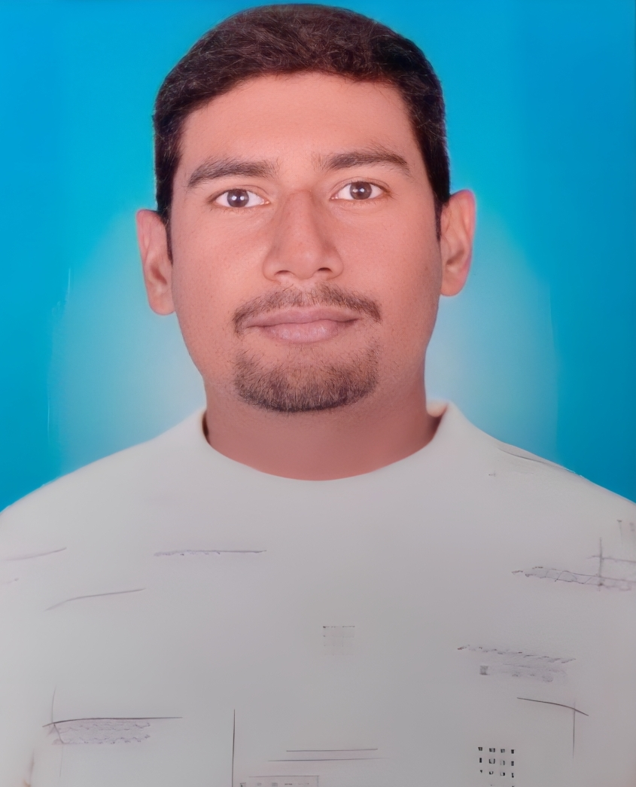

**DEVENDRA TIWARI Mob.-9838235920,9616633612**  **Gmail id:-devendra200803@gmail.com ADDRESS:-Vill- Shivpur Post-Shivpur, Kohandaur,Patti, Pratapgarh,(U.P.)- 230401.**

**CAREER OBJECTIVE :-**

* To seek an opportunity for professional growth and increasing responsibility an organization.

Where term sprit and personal skill is recognized and my acquired knowledge may increase.

**EDUCATION QUALIFICATION :-**

* High school passed from U.P.Board in (2018)
* Intermediate passed from U.P Board in (2020)
* B.A. passed from Rajendra Singh(Rajju Bhaiya) University (2023)

**PERSONAL DETAILS:-**

Father,s Name :- Mr. Shambhu Nath Tiwari

Date of birth :- 20/08/2003

Gender :- Male

Religion :- Hindu

Marital Status :- Unmarried

Language Know :- Hindi& English

Hobbies :- sport

**DECLARATION:-**

* I hereby declare that all information given above is true at the best of my knowledge.

**Date:-** …………………………………

**Place:-**  **(DEVENDRA TIWARI)**